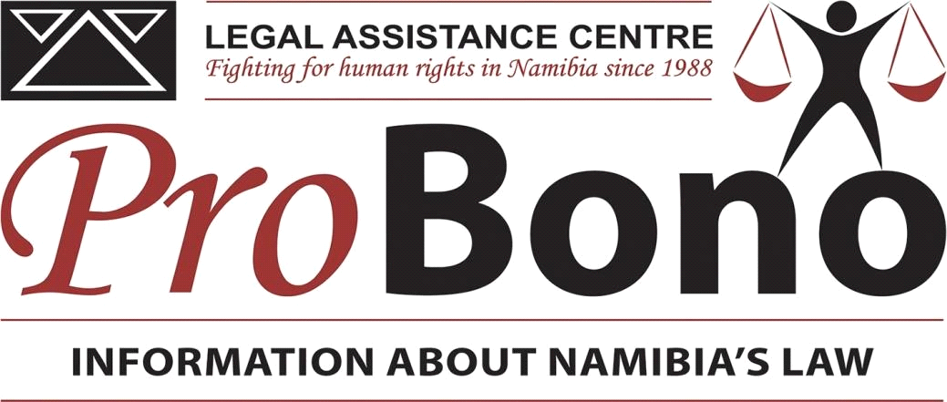

PROTECTING SAME-SEX COUPLES FROM DOMESTIC VIOLENCE

The current Combating of Domestic Violence Act is about to be amended. Currently, that Act protects people in “domestic relationships” as defined in the Act. One form of domestic relationship is couples who are cohabiting or in dating relationships - but the Act protects such relationships only between people “of different sexes”. Thus, same-sex couples are excluded from any protection under this law.
The Legal Assistance Centre believes that the forthcoming amendments to the Act should remove this limiting phrase, for several reasons.
1. Failing to protect persons in same-sex relationships from domestic violence may violate the Namibian Constitution. This could violate the constitutional right to dignity and protection against cruel, inhuman or degrading treatment (Art 8) or the right to equality before the law (Art 10(1)). Even though the Supreme Court of Namibia ruled in the 2001 Frank case that the existence of a same-sex relationship was irrelevant to an application for permanent residency, the Court explicitly stated that nothing it is decision “justifies discrimination against homosexuals as individuals” or deprives them of “the protection of other provisions of the Namibian Constitution”.
2. All persons living in Namibia, regardless of their sexual orientation, deserve the same protection from violence. Protecting same-sex couples from domestic violence does not mean that the government approves of or encourages such relationships. It merely fulfils government’s obligation to protect all persons in the Namibian house. It is a reality that some Namibians are living in same-sex relationships. Protecting same-sex couples against violence will not lead to more people living in such relationships; conversely, failing to protect same-sex couples from domestic violence will not discourage them from staying together. Providing protection would simply respect their rights.
3. Namibia’s National Human Rights Action Plan 2015-2019, drafted by the Office of the Ombudsman and approved by Parliament, identifies as a key intervention the need to “research and review laws and policies to identify provisions that discriminate against vulnerable groups”, including “sexual minorities”. The exclusion of same-sex couples from the protection from domestic violence is an example of such discrimination against “sexual minorities” – and on the issue of discrimination against vulnerable groups, the Plan includes a commitment to implement legal reform as necessary to implement “the right not to be discriminated against” (Focus Area 7).
4. International standards prohibit violence against people based on their sexual orientation. The African Commission on Human and Peoples’ Rights, in a 2017 resolution, strongly encouraged African States to end all acts of violence and abuse against persons because of their sexual orientation. It suggests doing so by “enacting and effectively applying appropriate laws prohibiting and punishing all forms of violence”.
5. The United Nations Human Rights Committee, which monitors the International Covenant on Civil and Political Rights, has expressed concern about the lack of protection for same-sex couples in domestic relationships in Namibia. In 2016, this Committee strongly urged Namibia to include same-sex relationships in the law’s protection Similarly, the United Nations Committee against Torture recommended in 2016 that Namibia “should take all necessary measures to protect lesbian, gay, bisexual, transgender and intersex persons from threats and any form of violence”.
6. Protecting same sex couples in domestic relationships would harmonize Namibia’s laws with the legislation of neighbouring countries. For example, South Africa’s Domestic Violence Act 1998 provides protection from domestic violence for both same-sex couples and couples of different sexes. Similarly, the definition of a “domestic partnership” in Botswana’s Domestic Violence Act 2008 does not require that the persons involved in such relationships must be of different sexes.
7. There are other Namibian laws that do not differentiate between same-sex couples and couples involving partners of different sexes. One precedent is the Combating of Rape Act, which uses gender-neutral language that covers sexual violence between persons of the same sex. Another example is the Criminal Procedure Act, which has a definition of vulnerable witness that includes a person “against whom any offence involving violence has been committed by a close family member or a spouse or a partner in any permanent relationship” - wording that would include partners of the same sex. Therefore, amending the Combating of Domestic Violence Act to protect persons in same-sex relationships against violence would not be a new step in Namibian legislation.
Everyone in Namibia deserves protection against the national scourge of domestic violence – regardless of sexual orientation, religion, or political beliefs. What kind of government would provide protection against violence only to people whose lifestyles it approves?
We urge Parliament to amend the domestic violence law to provide protection from domestic violence for persons living in same-sex relationships.

This article was made possible by support from the Hanns Seidel Foundation.

